**Introduction**

This is a document for rough sample diagrams/animations as included by the Physics research group.

**Fundamentals**

**Projectile Motion**

The basic idea is to have an object such as a cannon ball be shot up into the air and reach a specific maximum height, and fall back to the ground at distance d (change the range R to distance d).

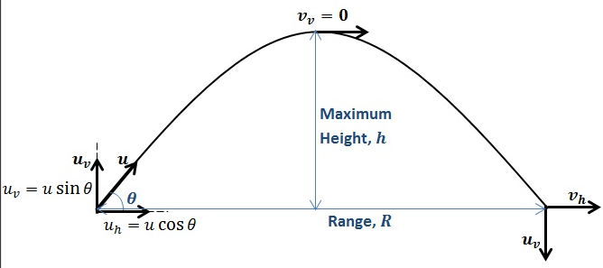

Start the projectile (cannon ball) at the bottom left corner

Can ask user for information such as: angle (Ɵ), and initial velocity (vi)

Once the user executes the animation, the object (cannon ball) will move according to user input

When the ball reaches the top, pause for 3-5 seconds

Have a notification pop up that says when height (h) is at maximum, y-velocity (vy) is zero. The ball will now begin to fall and the only thing affecting the y-velocity is gravity (in the downwards direction towards Earth)

‘Calculate height at each individual point to demonstrate the projectile motion

‘Initial time will be 0, and therefore height will be 0

‘Time must increment by any small number **n (eg. 0.001)** for the equation

‘The height change will be shown on screen depending on time (t)

‘Use equation d=viy(t) + ½(a)(t2) to calcualte the height based on the changing time

‘In the equation d is the height (vertical distance) viy is the vertical velocity calculated by vi*sin(Ɵ), both of which are given by the user (both vi and Ɵ), a is the acceleration which is -9.81

‘For a clear understanding of the equation, refer to the equation

‘Stop calculating (stop the loop) when the height is 0 (this means that the projectile has landed on the ground)

**Elastic Collisions**

Anyone who plays pool has observed elastic collisions.

Some kinetic energy is converted into sound energy when pool balls collide—otherwise, the collision would be silent—and a very small amount of kinetic energy is lost to friction.

However, the dissipated energy is such a small fraction of the ball’s kinetic energy that we can treat the collision as elastic.

[POOL BALL EXAMPLE 4 – Appendix 1]

Assume elastic collision between two particles of mass m1 and m2, respectively.

The velocities of the particles before the elastic collision are v1 and v2, respectively.

The velocities of the particles after the elastic collision are v1’ and v2’.

Applying the law of conservation of kinetic energy, we find:



Applying the law of conservation of linear momentum:



Elastic Collision Pool Ball

